

***Online Shopping System (OSS)***

**Final Release Document**

– Hanoi, Sep 2024 –

**Table of Contents**

I. Deliverable Package 3

II. Installation Guides 3

III. User Manual 3

1. Overview 3

2. Purchase Online Process 3

2.Product Management Process 3

# I. Deliverable Package

| **No.** | **File** | **Notes** |
| --- | --- | --- |
| 1 | [SE1878-JS(IT)_OS_G2_DB_final.sql](https://drive.google.com/file/d/1JxivozA80KipT2xDMzM5BsTJLpCvRBZG/view?usp=sharing) | Database, including both table structures and table data |
| 2 | [SE1878-JS(IT)_OS_G2_RDS_final.docx](https://docs.google.com/document/d/1FPCGWhKNR1RUQtQK-JitnvMNdFEF7YLVl8P_SFwIoDs/edit?usp=sharing) | Final RDS (Requirement) Document |
| 3 | [SE1878-JS(IT)_OS_G2_Product Backlog_final.xlsx](https://docs.google.com/spreadsheets/d/11pRf146rjNOsNqbPxyup_j3rucF9YBP2azbvwhGI-MM/edit?usp=sharing) | Final status for the application functions, which include:  - Function name, feature, roles, function description (changes compared to the original requirements are highlighted)  - In Charge, Planned iteration & Actual iteration  - Final status & note on the update you made  - The links to the SRS & SDS are tracked  -Video demo |
| 5 | [SE1878-JS(IT)_OS_G2_Project Tracking_final.xlsx](https://docs.google.com/spreadsheets/d/1_6dXgEVe15l3CCZWTGJD4eD6nwIrBdoYQBXUbkqtOpw/edit?usp=sharing) | Final tracking by iteration1,2,3 |
| 6 | [GROUP ASSESSEMENT.xlsx](https://docs.google.com/spreadsheets/d/1r1CR1gyx_cb_rwtndoI3Ui7yLig98MeX/edit?usp=sharing&ouid=107749378699712654969&rtpof=true&sd=true) | Final group assessment |
| 7 | [SE1878-JS(IT)_OS_G2_SlidePresentation_final.pp](https://docs.google.com/presentation/d/1oxX3awKda8QY35RN8LbRgCcxOS0kCZzA/edit?usp=sharing&ouid=107749378699712654969&rtpof=true&sd=true) | Presentation slide |

Other related deliverables:

* Tagged source codes: <https://gitlab.com/summer20241/se1875-sap/se1878-js-it/group02.git>
* Demonstration video: [SE1878-JS(IT)_OS_G2_Product Backlog_final.xlsx](https://docs.google.com/spreadsheets/u/0/d/11pRf146rjNOsNqbPxyup_j3rucF9YBP2azbvwhGI-MM/edit)

# II. Installation Guides

### Step 1: Install NetBeans 13

1. **Download NetBeans 13**:
   * Go to the [NetBeans download page](https://netbeans.apache.org/download/index.html) and download the installer for version 13.
2. **Install NetBeans**:
   * Run the installer and follow the on-screen instructions to install NetBeans 13.
   * Ensure that you check the box to install **Java SE** and **Java EE**.
3. **Open NetBeans**:
   * Once installed, open NetBeans 13 and configure it to use the JDK if prompted.

### Step 2: Install Apache Tomcat 10

1. **Download Apache Tomcat 10**:
   * Go to the [Apache Tomcat 10 download page](https://tomcat.apache.org/download-10.cgi).
   * Download the Core zip file under "Binary Distributions".
2. **Extract Tomcat**:
   * Extract the downloaded zip file to a directory, e.g., C:\apache-tomcat-10.
3. **Set Environment Variables (Optional)**:
   * You may want to add the CATALINA_HOME variable to your system environment variables, pointing to the directory where you extracted Tomcat.

### Step 3: Configure Apache Tomcat in NetBeans

1. **Open Server Settings in NetBeans**:
   * Go to **Tools > Servers**.
2. **Add Apache Tomcat Server**:
   * Click **Add Server**, select **Apache Tomcat or TomEE** and click **Next**.
   * Browse and select the Tomcat installation directory (e.g., C:\apache-tomcat-10).
   * Configure a username and password for the Tomcat manager (these credentials will be used to access the Tomcat Manager and deploy applications).
3. **Test Configuration**:
   * In the Servers window, right-click the Tomcat server and select **Start** to ensure that Tomcat starts correctly.

### Step 4: Open and Run the Project

1. **Open the Project**:
   * In NetBeans, go to **File > Open Project**.
   * Navigate to your source code location, select the project folder, and click **Open Project**.
2. **Configure the Project to Use Tomcat**:
   * Right-click on your project in the **Projects** panel and select **Properties**.
   * Go to **Run > Server**, select **Apache Tomcat** from the dropdown menu, and save the changes.
3. **Build and Deploy**:
   * Clean and build the project by right-clicking the project and selecting **Clean and Build**.
   * Once built, you can deploy the project by right-clicking and selecting **Run**.

### Step 5: Test the Application

1. **Access the Application**:
   * When the application starts, your default web browser should open to the application’s URL, typically http://localhost:8080/yourAppName.
2. **Verify**:
   * Check that all pages load correctly and that Tomcat is serving the application without issues.

# III. User Manual

## 1. Overview

The workflow describes how to buy items and add new product by actors in our online shopping system.

## 2.1. Purchase Online Process

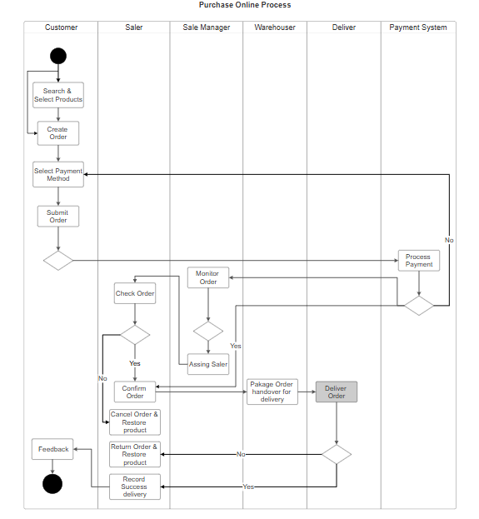

**1. Customer:**

* **Search & Select Products:** The customer searches for and selects the products they want to purchase.
* **Create Order:** The customer creates an order.
* **Select Payment Method:** The customer selects the payment method.
* **Submit Order:** After selecting the payment method, the customer submits the order.

After submitting the order, the flow moves to the **Payment System**.

**2. Payment System:**

* **Process Payment:** The payment system processes the payment for the submitted order.

If the payment is successful, the flow moves to the **Sale Manager** to continue the process.

if not, flow will move back to Cart Contact Page to select payment method again

**3. Sale Manager:**

* **Assign Saler:** The Sale Manager assigns a specific saler to handle the order.

**4. Saler:**

* **Check Order:** The saler checks the order after receiving it from the Sale Manager.

After checking, the saler has two options:

* If the order is valid, confirm the order and transfer it to the **Warehouser**.
* If there is an issue with the order, cancel the order, restore the product, and then return the order and restore the product.

**5. Warehouser:**

* **Package Order:** The warehouser packages the order after receiving it from the saler.
* **Handover for Delivery:** After packaging, the warehouser hands the order over to **Deliver** for shipping.

**6.Deliver:**

* **Deliver Order:** The deliverer receives the packaged goods and delivers them to the customer.

If there is an issue with the order, the saler returns the order. If not, the successful delivery is recorded.

**7. Customer:** The customer sends product feedback.

## 2. Product Management Process

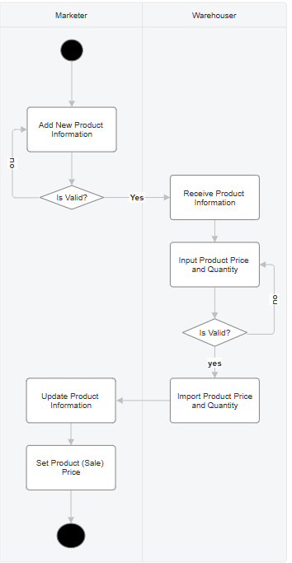

**Marketer:**

1. Add New Product Information: The Marketer is responsible for inputting the details of a new product, including the product name, description,..
2. Input Sale Price: The Marketer sets the sale price for the new product.
3. Update Product Information: The Marketer can update the existing product information as needed.

**Warehouser (Inventory Staff):**

1. Receive Product Information: The Warehouser receives the approved product details from the Marketer.
2. Import Product Price and Quantity: The Warehouser inputs the import price and the available quantity and size options, and color options. for the new product.
3. Validate Imported Information: The Warehouser checks if the imported information is correct. If it is, the inventory system is updated.